**Preparation of Papers for ICART 2025**

**Names of Authors1**

*1Full postal-mailing address, e-mail address, and affiliation of each author.*

**ABSTRACT**

The abstract (or, the title of the paper) need not be identical to that initially submitted but should be similar. The abstract must be a maximum of 300 words long and not contain any figures, tables, or references. It should present a concise statement of the scope, summary of work, principal findings, and conclusions of the paper.

**PAPER LENGTH**

The maximum permitted length for a paper is 6~8 pages.

**FORMAT**

**Submission.** Authors should be aware that the pages may be reduced in size for printing so very small details in figures may be lost.

**Point size and font.** Follow exactly the layout of this document. The text must be in 11-point “Times New Roman” font, except the paper title should be in 16-point (similar in style to the title above “**Instructions for Authors**”). Main headings (in 12-point) must be **BOLD UPPERCASE** and sub-headings (in 11-point) must be **Bold Lowercase,** both must be justified fully between margins (like the text layout of this document). The text must be justified fully between margins (like the text layout of this document). Within tables and figures, the 11-point font must also be used.

**Paper Title.** The paper title (**in bold**) should be centered on the top of the first page. Below the title, center all Names of Authors (**in bold**); and, also, include the following information: Full postal-mailing address, e-mail address, and affiliation of each author (in Italics and not in bold); and must be justified fully between margins (like the text layout of this document). One line must be left blank between the paper title and names of authors, between names of authors and their mailing addresses, and their mailing addresses and abstract.

**Layout.** All text must be single-spaced with one blank line above and below the main headings. The single-column format must be used with text justified fully between margins (like the text layout of this document). Leave one line blank between paragraphs. Do not indent the new sentence when starting a new paragraph. Figures and tables must be embedded in the text and should follow as soon as possible, without creating a short page, after the first time they are referred to in the text.

**Margins.** The margin settings are shown in Table 1. The first page of the paper must have an additional 2 cm. (0.8”) below the top margin. All text, figures, and tables must fit within the margins. Do not place any information in the header or footer. The tables and figures should be arranged so the area within the margins is filled, and short pages are not created.

**Table 1. Margin Settings**

|  |  |  |
| --- | --- | --- |
| Margins | 8.5” × 11” (letter) | 21 cm × 29.7 cm (A4) |
| Top | 1” | 3.4 cm (1.34 in) |
| Bottom | 1” | 3.4 cm (1.34 in) |
| Left | 1” | 2.23 cm (0.88 in) |
| Right | 1” | 2.23 cm (0.88 in) |

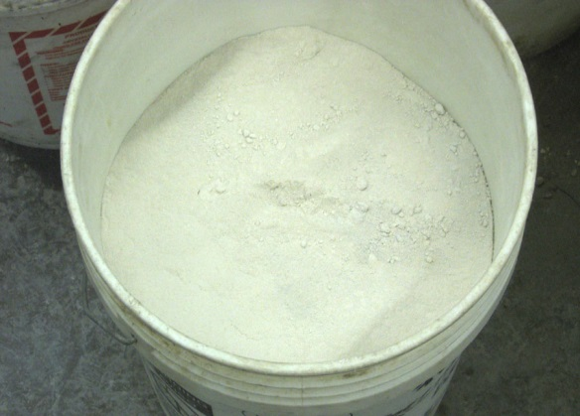

**Fig. 1. Powdered Gypsum-Wallboard**

**Captions and Legends.**  A descriptive caption, including a figure/table number, must be placed directly below the figures and above the tables.  Legends for figures should be accommodated in the figures themselves.  Captions for figures/tables must be exactly as shown above for Table 1, justified fully between margins (similar to the text layout of this document), with one blank line above and one below. Letters should be in 12-point font (**in bold**), with appropriate capital letters as shown above for Table 1 (**Table 1. Margin Settings**).

**Style.** The paper must be written in a third-person narrative, in clear and concise technically and grammatically correct English language. Authors must use short sentences. Papers will be rejected if the language is found to be inadequate. Authors must use generic names of products (the commercial name may be given the first time the generic name is given).

**Mathematics.** All mathematics must be embedded in the text. Equations must be numbered.

**System of Units**. MKS SI units must be used throughout the text, figures, and tables. Imperial/US Customary Units conversions may be placed in brackets after them.

**References.** All references that are cited in the text must appear together at the end of the paper; listed alphabetically. The Name-and-date (Harvard) system should be used so references should not be numbered; see the section below - **REFERENCES**.

**SUBMISSION**

Authors must submit their papers, *only through* ICART 2025 website. If any difficulty is encountered, please contact the secretariat at [icart@icart2025.kr](mailto:icart@icart2025.kr).

**REFERENCES (Must be listed alphabetically)**

Burka, L. P. (1993). "A hypertext history of multi-user dimensions." *MUD history, <*<http://www.ccs.neu.edu/home/1pb/mud-history.htm1>> (Dec. 5, 1994).

Fisher, J. W., and Stroik, J. H. A. (1974) *Guide to design criteria for bolted and riveted joints,* Wiley, New York.

International Conference of Building Officials (lCBO). (1997). *Uniform building code,* Whittier, Calif.

Kurtz, M. (1991). "Section 7: Transformation of space in computer graphics. "*Handbook of applied mathematics for engineers and scientists,* McGraw-Hill, New York, 7.1-7.42.

Mossberg, W. S. (1993). "Word isn't perfect but new WordPerfect is too much for words." *Wall Street J,* Dec. 2, B1.

Pennoni, C.R. (1992). "Visioning: The future of civil engineering." *J Profl. Issues in Engrg. Educ. And Pract.,* ASCE, 118(3), 221-233.