ㅣSponsorship/Exhibition Application Formㅣ

ICART 2025 Secretariat: E-mail: icart@icart2025.kr

1. Applicant Information
Company Name
President/CEO
Postal Address
Contact Person |  | Position
Telephone |  | Fax
E-mail |  | Website

2. Sponsorship & Exhibition ※ Apply (Check “O”)
Types | Level | Amount | Apply
Sponsorship | ICART 2025 + 2025 Autumn Conference of KSR | KRW 3,000,000
Sponsorship | Only ICART 2025 | KRW 2,000,000
Exhibition (2m * 2m) |  | KRW 1,500,000
Total

3. Payment
ICART 2025 requires payment in full before we can confirm your company’s participation at the conference. The sooner you send your form, the greater exposure your company will get via all conference-related correspondence and web presence.

4. Account Information
- Account Holder: The Korean Society for Railway
- Account Number: 630-010411-428
- Swift Code: KOEXKRSE
- Bank Name: KEB HANA BANK
- Address: Namdaemun Branch, 10 Tongil-ro,Jung-gu, Seoul 04527, Korea

□ Exhibition Booth Participation Guide
※ Participation Fee per Booth: 1,500,000 KRW
※ Booth Specifications:
▻ Booth Size: 2m (W) × 2m (D) × 2.5m (H)
▻ Provided Items:
- Free items include: 1 info desk (Item No. 10A on the supply list), 1 chair (Item No. 1), spotlight, fluorescent light, 2 power outlets
▻ Installation Company:
- Sung Ho Design – CEO Kang Sung Lee
(Phone: 010-3119-6778 / Email: sunghodesign@hanmail.net)
- For technical inquiries, please contact the booth installation company directly.
※ Side openings may not be possible depending on on-site conditions.

□ Booth Signboard Logo Insert Guide (Select one of the examples below)
Institution/Company Logo (Free of charge) : When inserting the logo of the institution/company | Default (Free of charge) : When displaying only the name of the participating institution/company in navy Gothic font on a white background
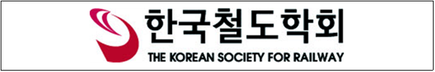  [Example 1: With Logo] | 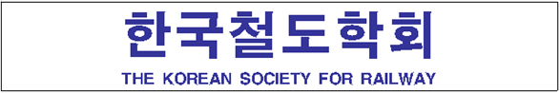  [Example 2: Default Text Only]
※ If logo work is required, please send the logo file as well. (AI file format preferred for editing)
※ The supply list and item photos are available on the next page.

□ Poster and Promotional Material Attachment Guide
※ If you wish to attach posters or promotional materials to the booth panel, you must use masking tape or 3M magic tape as shown in [Example]. Double-sided tape or OPP tape is not allowed.
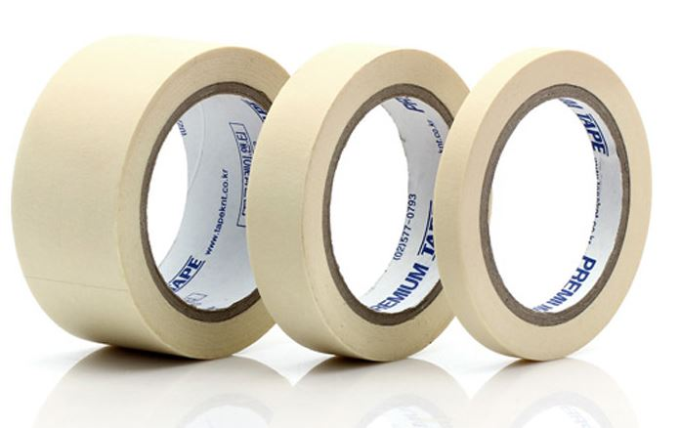 Masking Tape | 3M Magic Tape
※ Office supplies needed for attachment (tape, hooks, clips, cutter, etc.) will not be provided – please bring them yourself.
□ Exhibition Equipment Request List
※ Please refer to the next page for sample photos.

Item No. | Item | Unit Price | Quantity | Amount
1 | Folding chair | 11,000 | - | -
2 | Round chair | 16,500 | - | -
3 | Design chair | 22,000 | - | -
4 | Steel chair | 22,000 | - | -
5 | High stool | 77,000 | - | -
6A | DIA600mm Round table | 55,000 | - | -
6B | DIA750mm Round table | 55,000 | - | -
7A | DIA600mm High round table | 77,000 | - | -
7B | DIA750mm High round table | 77,000 | - | -
8A | 1200mmL Rectangular table | 55,000 | - | -
8B | 1800mmL Rectangular table | 88,000 | - | -
9A | 1000mmL Display base | 77,000 | - | -
9B | 2000mmL Display base | 154,000 | - | -
10A | 1000mmLx500mmD Display base | 44,000 | - | -
10B | 2000mmLx500mmD Display base | 88,000 | - | -
10C | 1000mmLx700mmD Display base | 55,000 | - | -
10D | 2000mmLx700mmD Display base | 110,000 | - | -
11 | Catalogue Holder(Folding) | 55,000 | - | -
12 | Laptop | 132,000 | - | -
13A | 42" LED TV. (stand included) | 400,000 | - | -
13B | 50" LED TV. (stand included) | 500,000 | - | -
13C | 60" LED TV. (stand included) | 600,000 | - | -
14 | Hot & cold water dispenser | 150,000 | - | -
15A | 150L Refrigerator | 150,000 | - | -
15B | 60L Refrigerator | 120,000 | - | -
16 | Guard Rail | 30,000 | - | -
17 | Spec Stand | 30,000 | - | -
18 | Parasol & Table | 250,000 | - | -
19A | System shelf(Slented) | 50,000 | - | -
19B | System shelf(horizontal) | 60,000 | - | -
20A | 720mmH Acrylic dome table | 250,000 | - | -
20B | 1000mmH Acrylic dome table | 300,000 | - | -
21 | Steel pipe chair | 80,000 | - | -
Total |  |  |  | -

